[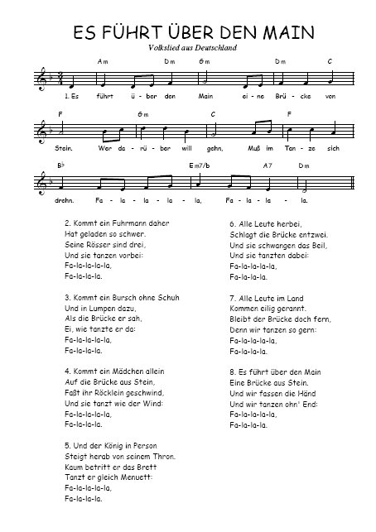](http://www.partitionsdechansons.com/telechargement_pdf.php?id=9908)